Guess Paper - 2008
Class – X
Subject – Social Studies

Q.1. Which powers wanted to control the Balkans?
Q.2 What is the main disadvantage of shifting cultivation?
Q.3 List the soil and climatic conditions suited for cultivation of rice.
Q.4 Why does India export iron ore even though we have to import certain varieties of steel?
Q.5 Social divisions may or may not lead to disintegration. Establish by one example of each case.
Q.6 State any two religious practices that involve discrimination based on gender
Q.7 Give one example to support that economic growth may be faster under dictatorship but it carries with it the risk of disintegration.
Q.8 All groups of people seek certain common developmental goals. Identify and list any two.
Q.9 List two ways an approaching tsunami may be detected.
Q.10 Identify any four constituents of a Resource Map.
Below are given three groups of A, B and C of questions 11 and 12. Select any one group for answering these questions.
GROUP A
Q.11. How were the small farmers in England affected by industrialisation? How did they respond?
Q.12 What measures are needed to ensure than the development of cities and environmental concerns are balanced? Give any one example.
GROUP B
Q. 11. Explain how mass production was an important feature of US economy in the 1920s.
Q. 12. Give three reasons for the Great Depression of 1929-30s.
GROUP C
Q.11 Explain the Bretton Woods system briefly and its impact. [3]
Q.12 Show that the Second World War was even deadlier than the first. [3]
Q. 13 The most exciting elements of the novel was the involvement of women.

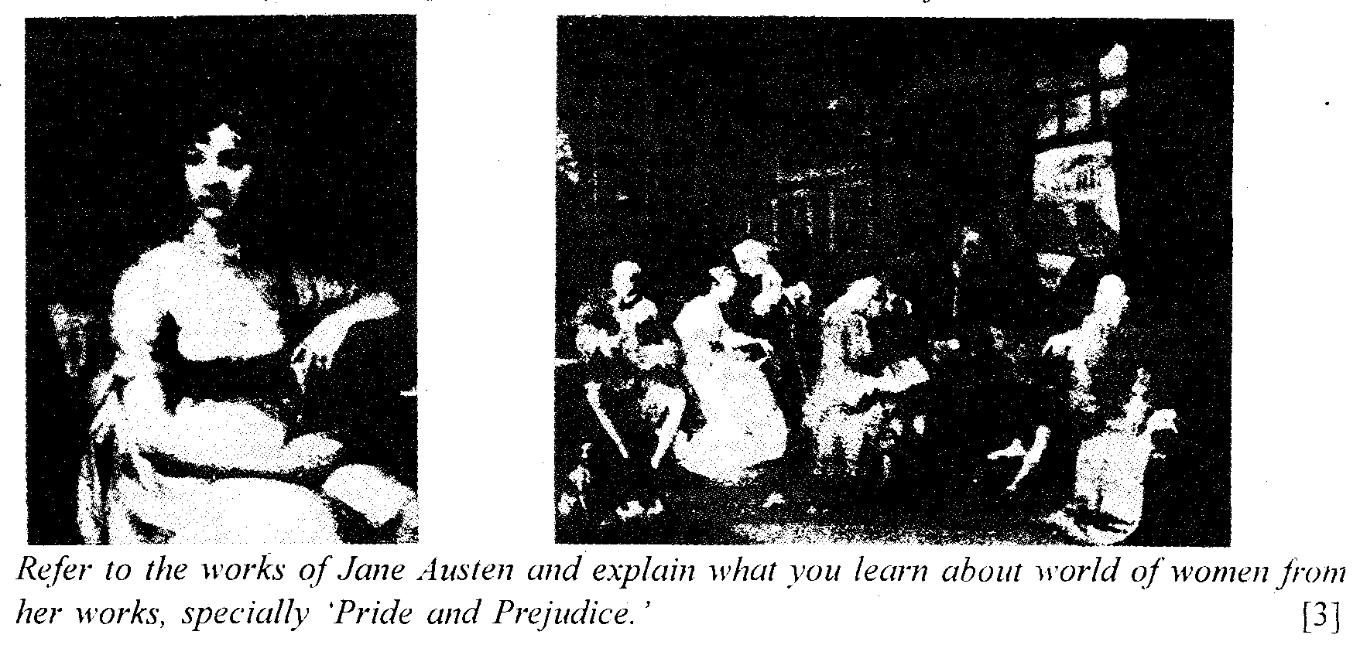
Q. 14 Give two points in favour of and two against building dams on rivers. Give comments on problems faced by persons ousted from reservoir sites.
Q. 15 which areas democracies must take care of minority considerations? Mention any three and explain any one of them briefly
Q.16 Why are rates for commodities of everyday use higher at convenience stores near our residences? Why are they still patronised?
Q.17 If you were the chief coordinator of District Relief Committee in a flood affected area, what other departments would you need assistance from? List any five.
Q. 18 What protection measures can help in minimnising damage to homes in flood prone areas?
Q.19 Why is existence of nations considered to be a good thing and even a necessity?
OR
Mention 3 features of the Ho-Chi-Minh Trail. What role did it play in the Vietnamese war?
Q.20 What was the significance of the Salt Satyagraha? How did the agitation spread over different parts of the country?
Q.21 What are the two types of metallic minerals? Give one example of each.
Q.22 What human factors (mention any four,) determine the location of industries in any one particular region? Illustrate your answer with appropriate examples.
Q.23 Explain with a suitable example the essential difference between a unitary and a federal system of government. Give any two reasons why a federal system is more suited to India.
Q.24 How are caste divisions different from divisions based on educational attainments? Why are some castes still backward educationally? Give any two reasons.
Q.25 Political parties in India face a number of problems. Identify any four and briefly comment upon any two of them.
Q.26 Mention any three ways in which consumers are exploited. What should the consumers do by way of precautions?
Q.27 Why is growth in manufacturing sector desirable as compared to growth in the services sector? Give three reasons.
Q.28 Explain briefly the functioning of Self-Help Groups in securing credit for their day to day needs.

Q. 29. On the outline map of India identify Raniganj, Digboi, Korba and Ankaleshwar
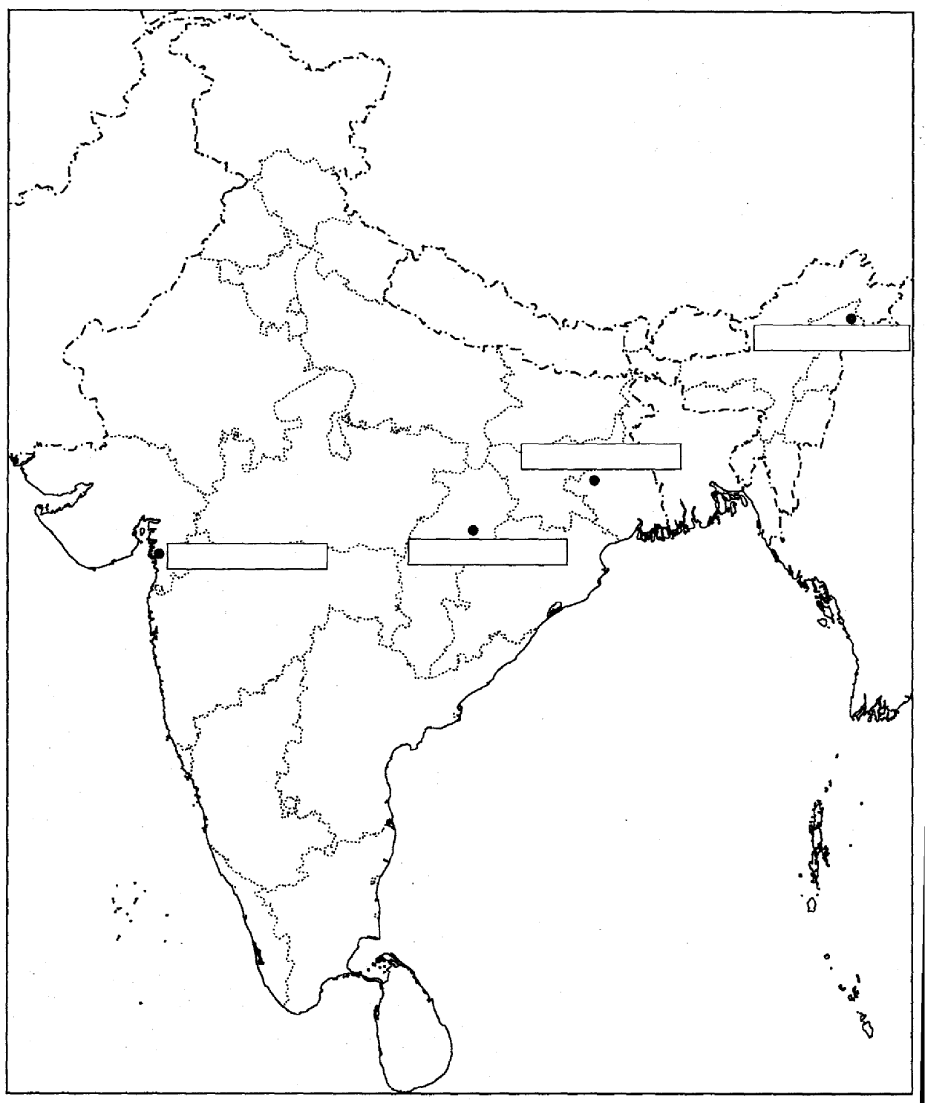
Q. 30 On the outline map of Africa label the following: (i) Northern Rhodesia (ii) Southern Rhodesia (iii) Madagascar (iv) Middle Congo

