Guess Paper – 2008
Class – X
Siubject – Science

General Instructions:
- The question paper comprises of two sections A and B. You are to attempt both the sections.
- All questions are compulsory.
- There is no overall choice. However internal choice has been provided in all the three questions of five marks category. Only one option in such questions is to be attempted.
- Questions 1 to 6 in section A and 17 to 19 in section B are short questions. These carry one mark each.
- Questions 7 to 10 in section A and 20 to 24 in section B are short answer type questions and carry two marks each.
- Questions 11 to 14 in section A and 25 to 26 in section B are also short answer type questions and carry three marks each.
- Questions 15 and 16 in section A and question 27 in section B are long answer type questions and carry five marks each.

SECTION ‘A’
Q.1 Why are ‘danger’ signal lights red in colour?
Q.2 Why were noble gases discovered very late?
Q.3 Name one natural plant material that can be used as an indicator.
Q.4 Light enters from air into glass of refractive index 1.5. What is the speed of light in glass? The speed of light in vacuum is 3 X 10⁸ ms ^{–1}.
Q.5 Why do silver articles tarnish after some time?
Q.6 Why are electric bulbs usually filled with chemically inactive gases such as nitrogen and argon?
Q.7 Draw the electron dot structure of cyclohexane. With which homologous series does cyclohexane share its general formula?
Q.8 With the help of chemical reactions, give reasons why:
- Respiration is considered an exothermic reaction?
- Silver can be recovered from silver nitrate by using copper metal?
Q.9 100 J of heat is produced each second in a 4Ω resistance. Find the potential difference across the resistor.
Q.10 Draw the pattern of magnetic field lines through and around a current carrying solenoid. How will the strength of the magnetic field be affected on?
- Decreasing the number of turns in the coil.
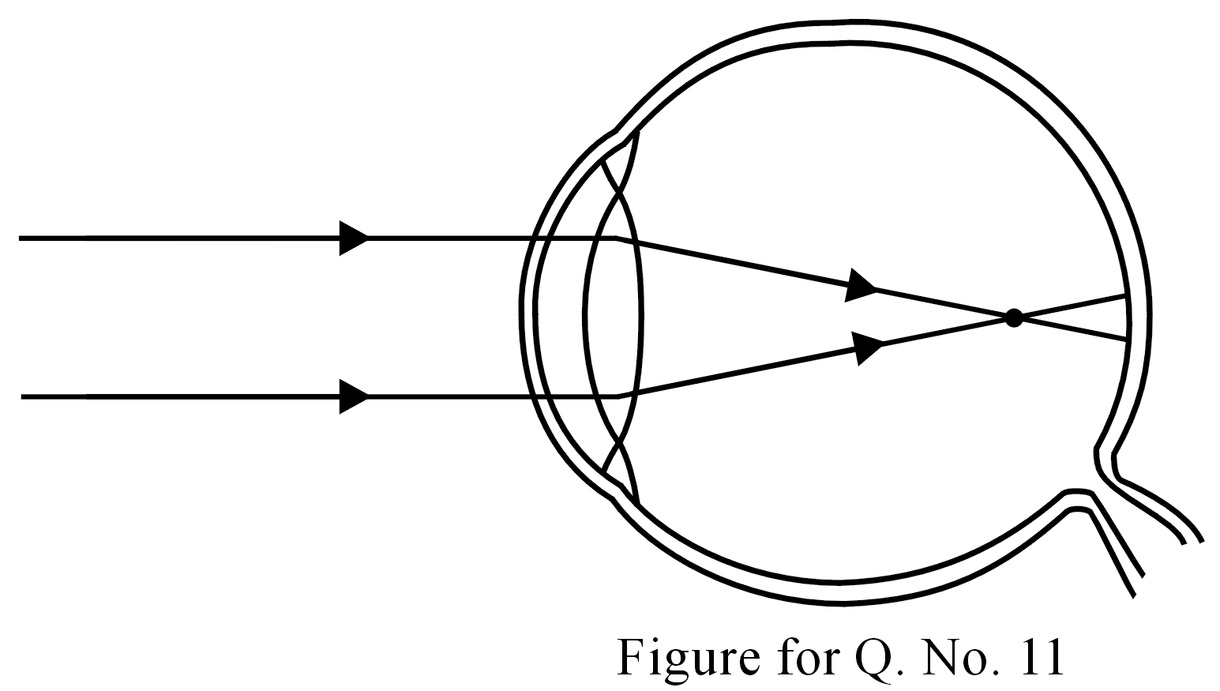
- Increasing the electric current passing through the coil.
Q.11 What defect is shown in the given figure?
- What is the cause of this defect?
- How is this defect corrected by using spectacles?
Q.12 With the help of chemical reactions, explain, in brief, what happens when:
- Cinnabar is roasted?
- Zinc carbonate undergoes calcination?
- Steam is passed over iron metal?
Q.13 Given below are the electronic configurations of the atoms of some elements:
Elements | Electronic configuration  K L M N O | Letters X, Y, Z, E, G, L, Q, R, and T. These letters are not the symbols for the elements concerned. By reference to the table answer the following questions:
X | 2 8 3
Y | 2 8 18 5
Z | 2 8 7 | (a) Which is a noble gas?
E | 2 8 18 8 1 | (b) Out of X, Z and G, which has the largest atomic size?
G | 2 8 2 | (c) To which period does E belong?
L | 2 5 | (d) Which elements belong to the same group?
Q | 2 8 18 8 | (f) Write the formula of the compounds formed when (i) G reacts with Y and (ii) X reacts with Z

Q.14 An object is placed at a distance of 10 cm from a concave mirror of focal length 20 cm. (a) Draw ray diagram for formation of the image; (b) Calculate the image distance; (c) state the characteristics of image formed.
Q.15 (i) Write the common name of ethanol.
(ii) Name two substances in which ethanol is an important constituent.
(iii) What happens (Give chemical equation) when sodium reacts with ethanol?
(iv) What happens (Give chemical equation) when ethanol is heated at 443K with excess of concentrated sulphuric acid?
(v) Why is the conversion of ethanol to ethanoic acid an oxidation reaction?

Or
(a) Explain the cleansing action of soaps? (2)
- What is hydrogenation? What is its industrial application? (2)
- What type of fatty acids are considered to be healthy and why? (1)

Q.16 (i) State the law that governs the strength of the current passing through a metallic conductor when a potential difference is applied across its ends. Illustrate this law graphically.
(ii) Three resistors each of resistance 10 Ω are connected, in turn, to obtain
(a) Minimum resistance and (b) Maximum resistance
Compute
- The effective resistance in each case.
- The ratio of the minimum to the maximum resistances so obtained.

Or
(i) State the law that governs the amount of heat produced in a metallic conductor when electric current is passed through it for a given time. Express this law mathematically.
(ii) Two resistors of resistances 2 Ω and 4 Ω are, in turn, connected
(a) In series and (b) In parallel to a given battery for the same time interval.
Compute the ratio of the total quantity of heat produced in the combination in the two cases.

SECTION ‘B’

Q.17 Which organelle of cell is the site of breakdown of pyruvates to give carbon dioxide, water and energy?
Q.18 Name two plants that show parasitic nutrition.
Q.19 What are considered ‘biodiversity hotspots’?
Q.20 Draw a neat and labelled diagram of a box type solar cooker.
Q.21 What is meant by rainwater harvesting? Mention the advantage of following this practice.
Q.22 A cow looses a lot of weight due to starvation? Will this character be transmitted as an inherited trait? Justify.
Q.23 Describe the characteristics of flow of energy in an ecosystem?
Q.24 (i) Label the four parts indicated by 1, 2, 3 and 4 in the diagram given below:
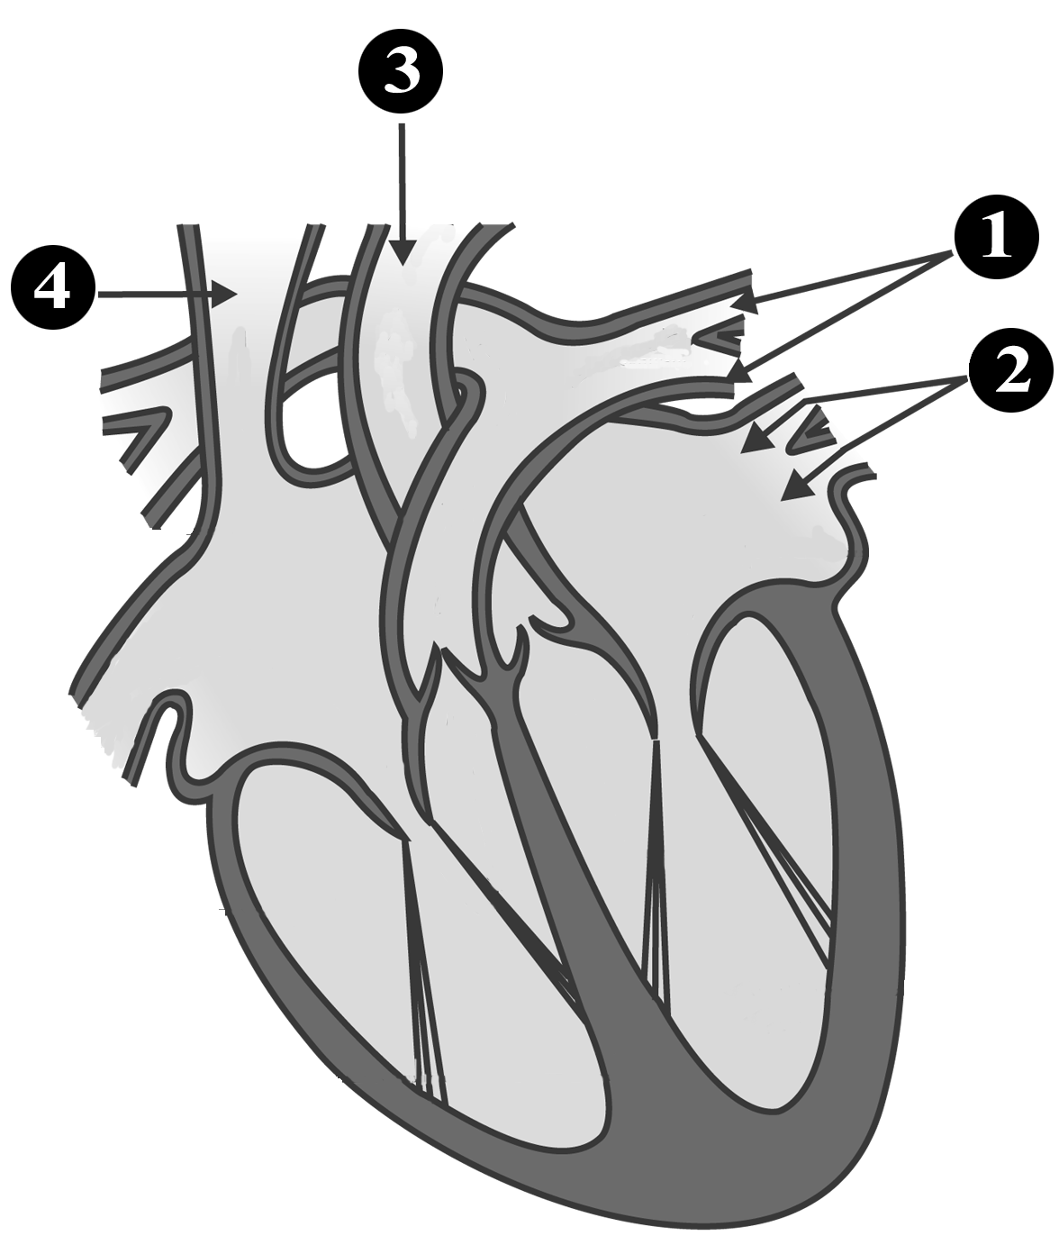
(ii) Mention the functioning of 1, 2, 3 and 4 in the above diagram.
Q.25 (i) Name the hormones secreted by testis and ovaries.
(ii) What is the role of sex hormones in the process of reproduction?
Q.26 Which component of sunlight is regarded as harmful to us? How is it normally prevented from reaching us? What can destroy this natural protection?
Q.27 With the help of a neat and labeled diagram, explain the structure and functioning of human digestive system.

Or
With the help of a neat and labeled diagram, explain the structure and functioning of human respiratory system

