Sample Paper - 2008
Class- XII
Subject – Multimedia and Web Technology

ime allowed : 3 hours Maximum Marks: 70
- Candidates must write the Code on the title page of the answer-book.
- Please check that this question paper contains 8 printed pages.
- Code number given on the right hand side of the question paper should be written on the title page of the answer-book by the condidate.
- Please check that this question paper contains 7 questions.
- Please write down the serial number of the question before attempting it.
___________________________________________________________________

- (a) Write down any three advantages of using a database system. 1
(b) Define the following terms 1
1. Alternate key OR Cartesian Product
2. Degree of relation OR Attribute
( c) What is the difference between Text and Memo data types ? 1
(d) Which types of fields are only support input mask ? 1
(e) Consider the following tables BANK and CUSTOMER. Study the following data and answer the question given below : 3
Table BANK
AccNo | Name | DB_Amt | CR_Amt | Balance | Tr_Date
5079 | Santosh | 10000 | 30000 | 200000 | 27-12-‘07
6875 | Ashish | 5000 | 45000 | 500000 | 29-12-‘07
5444 | Augestine | 7000 | 145000 | 1400000 | 22-12-‘07
9873 | Sanjay B. | 8000 | 2459700 | 2451700 | 30-12-‘07

Table : CUSTOMER
AccNo | Address | PhoneNo | Photograph | Sign_Sample
5079 | Sec-17 | 987652222 | C:\image\san.jpg | C:\image\ssig.jpg
9873 | Sec-16 | 986753333 | C:\image\bel.jpg | C:\image\bsig.jpg
(i) Suggest data types that should be used for each of the fields in the table BANK .
(ii) What type of relationship exist between the table BANK and the table CUSTOMER .
(iii) Name the field that can be set as a foreign key in the table CUSTOMER.
(f )How is freeware different from Shareware ? 1.5
(g)Give some examples of Open Sources / Free Software and write their characteristics: 1.5

2. . Questions given below are based on Macromedia Flash:
a) Write one difference between key frame and blank key frame . 1
b) Differentiate between a symbol and an instance . 1
c) What is the meaning of Skewing object ? 1
d) What is gap size ? 1
e) Define the term timeline and stage ? 2

f) Observe the figure given bellow and do as directed : 4
- The image on the left side shows the position of the image for frame 1.
- The image on the right side shows the position of the image for frame 50.
- The dotted line shows the path of motion of image.
Write procedure and property setting for animating the above scenario.

3 . Question given below are based on HTML:
- What is the use of IMG TAG ? Name all the attributes of IMG TAG . 1
- What is the difference between <P> and <BR> tag? 1
c) Write the HTML code to generate a Web Page in the format given below : 8
Consider the following while writing the HTML code :
1. Background colour of the page should be “Yellow”, text colour should be blue and visited link colour should be “Green”.
2. Title of the page is “Radio India”.
3. Text colour of main heading on the page should be “Maroon”.
4. Font face of text in the page should be “Arial”.
5. Picture used in the page is the file “music.jpg”.
6. Use the concept of nested list to display the given list.
7. Pages linked to :
Film Music as “film.html”
Classical Music as “class.html”
Sports as “sports.html”
8. The table should have a caption “Listener’s Choice - Top 5", a border of
2 pixels and the background colour of the first row should be “Aqua”.

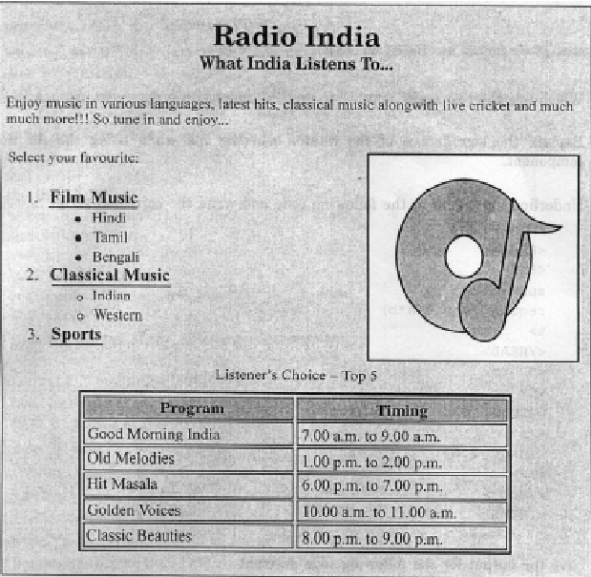
4.
- Explain the difference between server side script and client side script . 1
- Explain the usage of the “OPTION EXPLICIT” keyword with an example. 1
- What is builtin function ?Name any three function which are used in ASP program. 1
- How FOR ..NEXT is different from DO WHILE …LOOP ? explain with syntax .1
- How is call by value is different from call by reference method ? 1
- Differentiate between property and method with the help of an example ? 1
- Differentiate between remove and remove all methods in session object . give example. 1
- Find output 3
- Response.write(mid(“ WEB TECHNOLOGY”,3,abs(10 mod 3^1^30 -8))
- Response.write(instr(“mistrust or DISTRUST” , “IS”)
- Response.write( LEFT (“ CLASS XII , HOUR(#4:30:10 AM#)

5. a. Convert the following coding in to for ………..next loop 2
<html>
<body>
<%
dim a,b,c,d,e,sum
a=1,b=2,c=3,d=4,e=5
do while b<10
sum=a+b+c+d+e
a=a+3
b=b+7
c=c-3
d=d*4
e=e/2
loop %>
</body>
</html>
b. Find the errors in the following ASP code 2
<html>
<body>
<%
s=” Dynamic Array”
for I = 1 upto 7 skip 2
n=mid(s,I,2)
response.write (n)
document .write(“<br>”)
loop %>
</body>
</html>
c. Find the output of the following ASP coding 2
<html>
<body>
<%
i=1
atx=array(10,20,30,40,50,60)
max=ubound(atx)
do while(i<=max)
atx(i)= atx(i)\3
i=i+2
response.write(atx(i))
loop %>
</body>
</html>
d) Write an ASP program to read a text file named “mytext.txt” and display the contents of the file on the screen after converting all alphabets to upper case letters and replacing all spaces with “#”. 4
For example if the file contains the text :
Work is Worship.
The program should display :
WORK#IS#WORSHIP.

6. a) what is comment in VBScript ? explain with example ? 1
b) Change the following script using Do while …….. loop without affecting the output: 2
<Script language="VBScript">
sub result()
dim i,r,rev,k
k=1023456789
for i = 1 to 10 step 1
r=k mod 10
rev=rev*10+r
k=k\10
next
end sub
</SCRIPT>
c) Give the output for the following script code: 2
<Script Language="VBScript">
sub result()
dim feb1,feb2,feb3,i
feb1=1
feb2=2
document.write( feb1 & “<br>” & feb2)
do while i<5
feb3=feb3+feb1*feb2
document.write(feb3-10)
feb1=feb2
feb2=feb3
loop
end sub
</Script>

d)Rewrite the following code after correcting the errors: 2
<”script language” =vbscript>
sub result()
dim N1,N2,SUM,I
N1=inputbox(“enter number”)
N2 =inputbox(“enter number”)
For I=N1 to N2 step 2
loop
sum=N1+N2
if sum=100
exit for
end loop
end sub
</script>
e ) Write the HTML code for creating the form given below and also write the
embedded VBScript code for the click event of the “Calculate Cost” button,
should call a function “calculate()” which will calculate the total cost of the
items bought and displays it in an message box. For example if the user
selects T-Shirt as the item and enters the number of items as 2 then the total
cost will be Rs. 600. 3

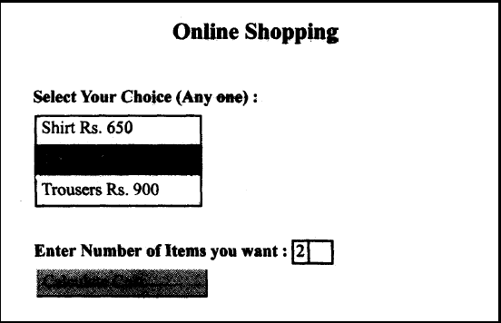

7.
a. What is computer network ? Explain its different components . 1
b. Write a short note on 1
Circuit, Message, Packet switching
c. Differentiate the following transmission 1
Serial and Parallel
d. Define the following network devices : 1
RJ45 Connector, bridge
e. Write short notes on the following communication protocols: 1
SLIP,SMTP, Telnet.
f. Explain the following network security concepts. 1
Cookies , Crackers.
(e)
Icon Multimedia Inc. is a big organization and has 4 wings where it runs its operations (shown below) : 4

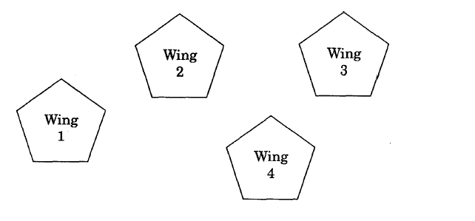

The distances between the different wings are given below :
Between 1 and 2 60 mts.
Between 2 and 3 40 mts.
Between 3 and 4 35 mts.
Between 1 and 4 110 mts.
Between 2 and 4 65 mts.
Each wing contains following number of computers :
Wing No. of Computers
1 50
2 150
3 60
4 55
Answer the following questions based on the above given information :
(i) Suggest suitable cable layout(s) for connecting the wings.
(ii) Where do you think the server should be placed and explain why ?
(iii) Suggest the type of cable that should be used if the organization wants to send
large amount of multimedia files and requires fast access.
(iv) The company also has an office in another city. How can link be established
with this office (suggest transmission medium) ?

******************

