ICSE Guess Paper – 2008
Class – X
Subject – Mathematics

F.M. – 80 Time – 2½ hrs.

01. (a) Ms. Chawla goes to shop to buy a mobile set, costing Rs. 1100/-. The rate of sales tax is 10%. He requested the shop-owner to reduce the price to such an extent that she has to pay Rs. 1100/- inclusive of sales tax. Find the reduction needed in the price of the mobile. (3)

(b) If p(x) = (x³ + 1) (x – 1) and Q (x) = (x² – x + 1) (x² – 3x + 2), find the H.C.F. and L.C.M. of p(x) and Q(x). (3)

02. (a) If (a + 3b + 2c + 6d) (a – 3b – 2c + 6d) = (a + 3b – 2c – 6d) (a – 3b + 2c – 6d) prove that a:b = c:d (3)

(b) Let A x $\begin{aligned}\left[1\text{ 1} | \right] \\ \end{aligned}$ = $\left[1\text{ 2}\right]$ Where A is a Matrix
(i) State the order of Matrix A
(ii) Find the matrix A (3)

03. (a) The midpoint of the line joining (2a, 4) and (-2, 3b) is (1, 2a + 1). Find the values of ‘a’ and ‘b’. (3)

(b) Find the range of values of ‘x’ which satisfies
- $2\frac{2}{3}$ < x + $\frac{1}{3}$ < 3$\frac{1}{3}$, x E R
represent your solution on a number line (3)

04. (a) Evaluate : tan 7° tan 23° tan 60° tan 67° tan 83° (3)
(b) If f(x) = x³ - $\frac{1}{x^{3}}$, show that f (3) + f $\left(\frac{1}{3}\right)$ = 0 (3)

05. (a) The price of Rs. 2000/- shares of TATA is Rs. 2500/- and the company declares a dividend of 20%. Find how many shares can be purchased out of Rs. 40000/- and also calculate the dividend and percentage return. (4)
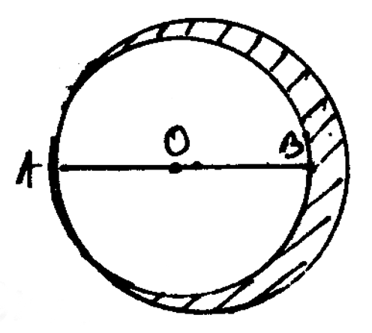
(b) Find the area of the shaded region if AO = 5 cm., AB = 8 cm.
where ‘O’ is the centre of big circle and AB is the diameter of
the smaller one. (4)

06. (a) A page from the saving account of Mr. Halder is given below calculate the interest at the end of the year at 6% p.a. (5)

Date 2007 | Particulars | Debit | Credit | Balance
January 1 | By Balance |  |  | 2000
January 8 | By Cash |  | 200 | 2200
February 10 | By Cash |  | 300 | 2500
February 24 | To Cheque | 500 |  | 2000
July 18 | By Cash |  | 500 | 2500
July 30 | To Cheque | 700 |  | 1800
November 8 | By Cash |  | 300 | 2100
November 9 | By Cash |  | 300 | 2400
November 10 | By Cash | 300 |  | 2100
December 9 | By Cash |  | 200 | 2300

(b) The marks of 20 students in a test were as follows -
5, 6, 8, 9, 10, 11, 11, 12, 13, 13, 14, 14, 15, 15, 15, 16, 16, 18, 19, 20
calculate – (i) Mean, (ii) Median, (iii) Mode (3)

SECTION – B
Attempt any four

07. (a) A sum of certain money is lend at 4% half-yearly, amounts to Rs. 5202/- in 1 year. If it had been lend for same time at the same rate in C.I., payable yearly, then how much he is earning more is half-yearly.` (4)

(b) If x² – 3x + 2 is factor of x⁴ – ax² + b, find a, b (4)

(c) Solve for x : if 2x =$\sqrt{3x+1}$ (2)

08. (a) A chess board contains 64 equal squares and the area of each square is 6.25 cm².
A border round the board is 2 cm. wide. Find the length of the side of chess board. (4)

(b) Miss Rawaf’s salary is Rs. 32,250/- per month exclusive HRA. She donates
Rs. 12,000/- to P.M’s relief fund (100% exemption). She also donates Rs. 6000/- to a school and gets a relief of 50% on this donation. She contributes Rs. 5000/- per month towards her P.F. She pays a quarterly premium of Rs. 2500/- towards her L.I.C. policy and invest Rs. 25000/- in N.S.C. If Rs. 2700/- is the tax deducted each month from her salary for 11 months, find the tax deducted from her salary in the last month of the year. Use the following to calculate :

(a) | Savings | 100% exemption for permissible  savings up to Rs. 1,00,000/-
(b) | Rates of Income Tax for ladies | Income Tax
 | (i) Up to Rs. 1,35,000/- | No Tax
 | (ii) From Rs. 1,35,001/- to Rs. 1,50,000/- | 10% exceeding Rs. 1,35,000/-
 | (iii) From Rs. 1,50,001/- to Rs. 2,50,000/- | Rs. 1500/- + 20% exceeding  Rs. 1,50,000/-
 | (iv) Rs. 2,50,001/- and above | Rs. 21500/- + 30% of the amount  exceeding Rs. 2,50,000/-
(c) | Educational Cess | 2%

(6)
09. (a) The point C (3,4) is reflected in the x-axis. Then C' is the image of C. Again O' is the image of the origin O in the line CC'. Again O' is the image of the origin O in the line CC'. Find –

(i) Co-ordinate of O' and C'
(ii) Length of CC'
(iii) Perimeter of the figure COC'O'
(iv) Special name for COC'O' (4)

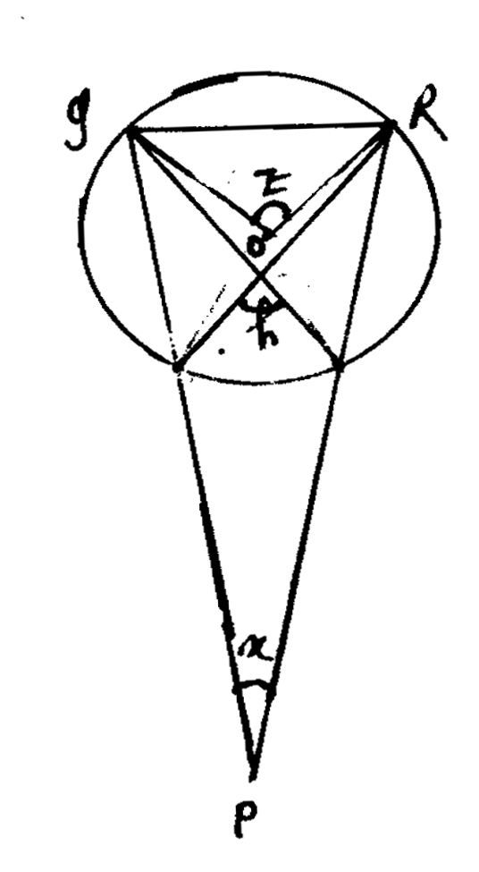
(b) If O is the centre of the circle
Prove that < x + < y = < z (3)

(c) Prove the identity :

${\left(\frac{\text{1 - tan}θ}{1−\text{cot}θ}\right)}^{2}={\text{tan}}^{2}θ$ (3)

10. (a) By using ruler and compass only :
Construct an isosceles triangle ABC in which BC = 6 cm, AB = AC and <BAC = 90°. Locate the point P such that P is equidistant

(i) from the sides BC and AC
(ii) the vertex B and C (3)

(b) In the given figure PA, QB and RC are each perpendicular to AC
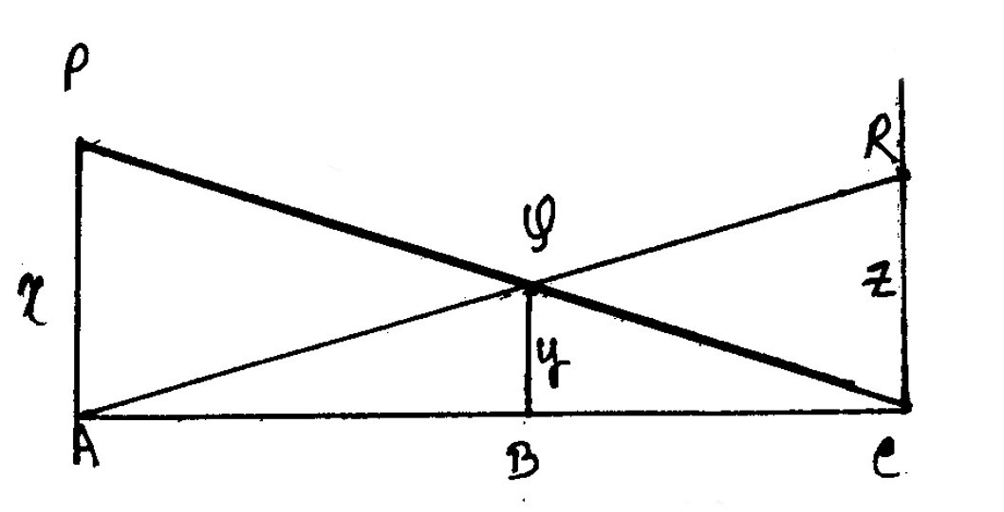
Prove that $\frac{1}{x}$ + $\frac{1}{z}$ = $\frac{1}{y}$ (3)

(c) A(0,4), B(3, -4) and C(-1, -2) are the vertices of triangle ABC, find
(i) the equation of Median through A
(ii) the equation of altitude through A. (4)

11. (a) Construct a ΔPQR is which PQ = PR = 3 cm and PR = 2 cm. Using rule and compasses only, draw the reflection P'QR of ΔPQR, in PR. Draw the lines of symmetry of the figure PQP'R (3)

(b) A right circular cylinder having diameter 12 cm and height 15 cm is full of ice-cream, the ice-cream to be filled in cones of height 12 cm and diameter 6 cm. having a hemispherical shape on the top. Find the number of such cones which can be filled with ice-cream. (4)

(c) If a : b = 1 : 2, find (4a² + 7b²) : (5a² – 11b²) (3)

12. (a) The shadow of a flagstaff is three times as long as the shadow of the flagstaff when the sunrays meet the ground at an angle of 60°. Find the angle between the sunrays and ground at the time of longer shadow. (4)

(b) The following table gives the weekly wages of in a factory. Draw an ogive for the given data.

Weekly wages in Rs. | No of worker
50 – 55 | 5
55 – 60 | 20
60 – 65 | 10
65 – 70 | 10
70 – 75 | 9
75 – 80 | 6
80 – 85 | 12
85 – 90 | 8

Use this ogive to find
(i) median
(ii) the upper quartile
(iii) the number of workers getting Rs. 65/- or more but less Rs. 85/- as weekly
wages. (6)

