ICSE Guess Paper - 2008
Class - X
Subject - Physics

CH. – 8 CURRENT ELECTRICITY

Question – 1. Mention two factors on which the resistance of a wire depends.

Question – 2. Mention two factors on which the internal resistance of a cell depends.

Question – 3. State Ohm’s law. Write an expression for the resistance of a conducting wire in terms of its length and area of cross section.

Question – 4. Distinguish between potential difference and emf of a cell.

Question – 5. Derive an expression for equivalent resistance when two resistors of resistance R₁ and R₂ are connected in (i) parallel and (ii) series.

NUMERICALS

Numerical – 1. A cell supplies a current of 0.6 A through a 2 ohm coil and a current of 0.3 A through a 8 ohm coil. Calculate the emf and the internal resistance of the cell.
Solution :- Here, I₁ = 0.6 A, R₁ = 2 Ω, I₂ = 0.3 A, R₂ = 8 Ω, r = ?
Using, I = E/(R + r), we get
0.6 = E /(2 + r) --- --- --- --- (i)
0.3 = E / (8 + r) --- --- --- --- (ii)
from (i) and (ii) we get 0.6(2 + r) = 0.3(8 + r)
or, 0.3 r = 1.2
or, r = 4 ohm.
Substituting the value of r in equation (i) we get
E = 0.6(2 + 4) 3.6 V
Hence, r = 4 ohm, E = 3.6 V. [Ans.]
Numerical – 2. Four cells each of emf 2 V and internal resistance 0.1 ohm are connected in series. The combination is connected in series to an ammeter of negligible resistance, a 1.6 ohm resistor and an unknown resistor R₁ . The current in the circuit is 2 A. Draw a labelled circuit diagram for the above arrangement and calculate :
(i) the total resistance of the circuit
(ii) the total emf
(iii) the value of R₁
(iv) the potential difference across R₁.
Solution :- The labelled circuit diagram is given below :
Fig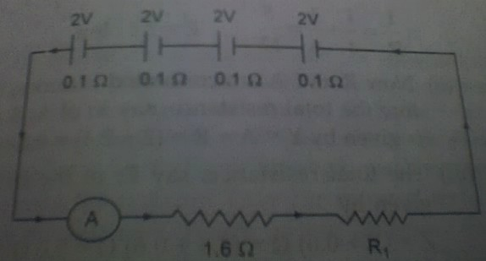
Total internal resistance = 4 × 0.1 Ω = 0.4 Ω
(i) Total resistance = 1.6 + 0.4 + R₁ = (2 + R₁) Ω
(ii) Total emf = (2 + 2 + 2 + 2) V = 8 V
(iii) Using, I = total emf / total resistance
or, 2 = 8 / (2 + R₁)
or, 2R₁ + 4 = 8
or, R₁ = 2 Ω
(iv) Potential difference across R₁ = I R₁ = 2 × 2 = 4 V
from (i) total resistance = 2 + R¹ = 2 + 2 = 4 Ω

Numerical – 3. Four cells each of emf 1.5V and internal resistance 2 ohm are connected in parallel. The battery of cells is connected to an external resistance of 2.5 ohm. Calculate :
(i) the total resistance of the circuit
(ii) the current flowing in the external circuit and
(iii) the drop in potential across the terminal of the cells.
Solution :- The arrangement of the four cells in parallel is as under :
Fig. 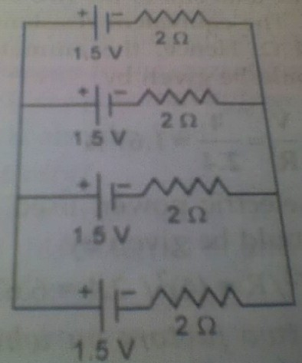
(i) As the cells are connected in parallel, the net emf of battery = 1.5 V,
Let the net internal resistance be r
Therefore, 1/r = 1/2 + 1/2 + 1/2 + 1/2 = 2 or, r = 0.5 Ω
(ii) The total resistance R of the circuit is given by
R = 0.5 + 2.5 = 3 Ω
Current flowing in the circuit, I = V/R = 1.5/ 3 = 0.5 A
(iii) Potential difference across the battery, V = IR = 0.5 ×2.5 = 1.25 V

Numerical – 4. Four resistances of 2.0 Ω each are joined end to end to form a square ABCD. Calculate the equivalent resistance of the combination between any two adjacent corners.
Solution :- In this situation three resistors are connected in series and their combination in parallel with the fourth resistor as given below :
Fig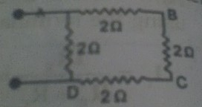.
By series combination we get, 2 + 2 + 2 = 6 ohm
This 6 ohm resistor is connected in parallel with fourth 2 ohm resistor. Let the resistance of the combination be R
Therefore, 1/R = 1/6 + 1/2 = 2/3
Hence, R = 3/2 ohm.

Numerical – 5. The following circuit diagram shows three resistors 2 ohm, 4 ohm and R ohm connected to a battery of emf 2 V and internal resistance 3 ohm. A main current of 0.25 A flows through the circuit.

Fig
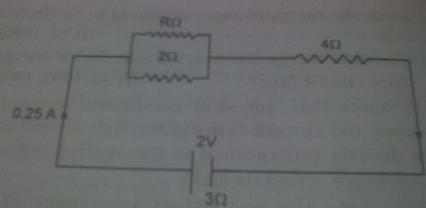.

(i) What is the pd across the 4 ohm resistor ?
(ii) Calculate the pd across the internal resistance of the cell.
(iii) What is the pd across R and 2 ohm resistors ?
(iv) calculate the value of R.
Solution :-

