SOLUTION & ANSWER FOR AIEEE-2008
[Mathematics]

71. Let f : N ® Y be a function defined as ……….

Ans: g(y) = 

Sol:y = 4x + 3
x = 
g(y) =

72. Let R be the real line. Consider the following…..

Ans: T is an equivalence relation on R but S is not

Sol:S = {(x, y): y = x + 1 0 < x < 2
(x, x) ® x = x + 1 ® not reflexive
(x, y) ¹ (y, x) ® not symmetric

73. The conjugate of a complex number is …….
Ans:

Sol:
Conjugate number = 
=

74. The quadratic equations x² - 6x + a = 0 and ……

Ans: 2

Sol:Let a , b be the roots of x² - 6x + a = 0 and a , g be the roots of x² - cx + 6 = 0
Þ a + b = 6 a + g = c
and
a b = a a g = 6
and 
\ a 
\ The first equation is x² - 6x + 8 = 0
Þ 2 and 4 are the roots.
If b = 2, then g = Þ Not possible, since roots are integers
If b = 4 Þ g = 3 Þ possible
\ The common root is 2

75. Let A be a square matrix all of whose entries……

Ans: If det A = ± 1, then A⁻ ¹ exists and all its
entries are integers

Sol:If det A ¹ ± 1, then det A may be zero Þ A⁻ ¹ does not exist.
When det A = ± 1, then A is orthogonal
Þ A⁻ ¹ = A^{T} Þ A⁻ ¹ will have all enteries as integers

76. Let a, b, c be any real numbers. Suppose…….

Ans: 1

Sol: x - cy - bz = 0
- cx + y - az = 0
- bx - ay + z = 0
Given that x, y, z not all zero.
Þ The given homogeneous system has non-trivial solutions.
Þ  = 0
Þ 1(1 - a²) + c(- c - ab) - b(ac + b) = 0
Þ - a² - b² - c² - 2abc + 1 = 0
Þ a² + b² + c² + 2abc = 1

77. How many different words can be formed by ……

Ans: 7.⁶C₄.⁸C₄

Sol: 4I, 2p, 4s and 1 M are there in MISSISSIPPI .
Arrange the remaining 7 letters ®
* - * - * - * - * - * - * - *
In the eight places in between (marked as *) we can arrange the 4s’s in ⁸C₄.wsays
\ Total number of words = 
= 7.⁶C₄.⁸C₄

78. The first two terms of a geometric progression….

Ans : - 12

Sol: a + ar = 12
ar ² + ar³ = 48
r ² (a + ar) = 48
r ² = 4
r = ± 2
r = - 2, since terms are alternately positive and negative
a = 

79. Let f(x) =  ……..

Ans : f is differentiable at x = 0 but not at x = 1

Sol : f(x) = 

= 
= 
f’(1) = 
= 
= 
does not exist

80. How many real solutions does the equation……..

Ans: 1

Sol:f(x) = x⁷ + 14x⁵ + 16x³ + 36x - 560
f'(x) = 7x⁶ + 70x⁶ + 48x² + 30
> 0 for all x Î R
f(x) is monotonic increasing
f(x) = 0 has only one real solution

81. Suppose the cubic x³ - px + q has three distinct..

Ans: The cubic has minima at and maxima
at -

Sol:f(x) = x³ - px + q
f'(x) = 3x² - p
f”(x) = 6x
3x ² = p Þ x = ±
f(x) is minimum at x = and
maximum at x = -

82. The value of  is ………..
Ans: x + log

Sol: 
= 
= 
= x + log

83. The area of the plane region bounded by the …..

Ans:

Sol:x + 2y² = 0 Þ x = - 2y²
x + 3y ² = 1 Þ x = 1 - 3y²

1
0
−1
−2
−1
x = −2y²
x = 1 − 3y²
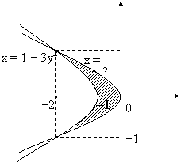

Shaded portion is the required area
Required area = 
= 
=

84. Let I =  and J = …….

Ans : I < 
Sol : I = 
< 
< 2
J = 
<
< 2
In (0, 1) Þ sin x < x

I < 

85. The differential equation of the family of circles…

Ans: (y - 2)² y’² = 25 - (y - 2)²

Sol : (x - h)² + (y - 2)² = 25
2(x - h) + 2(y - 2) = 0
(x - h) = - (y - 2)
Differential equation is
(y - 2)² = 25

86. The solution of the differential equation ……

Ans: y = x ln x + x

Sol:Put y = Vx

\ V + 
V + = 1 + V
x 
\ V = log x + C

y(1) = 1 Þ C = 1
\ = log x + 1
y = xlogx + x

87. The perpendicular bisector of the line segment ...

Ans: - 4

Sol : Slope of the line = = k - 1
Passes through 
Perpendicular bisector is
y - = (k - 1) 
2y - 7 = 2x(k - 1) - (k² - 1)
2x(k - 1) - 2y = k² - 8
 = - 4
k ² - 8 = 8
Þ k = ± 4

88. The point diametrically opposite to the point
P(1, 0) on the circle……..

Ans: (- 3, - 4)

Sol:Centre (- 1, - 2) . P(1, 0)
\ opposite point Q(x, y)
\ mid point of PQ = Centre
\  
x = - 3, y = - 4
\ Point (- 3, - 4)

89. A parabola has the origin as its focus and the …..

(0,0)
(1, 0)
x = 2
 Ans: (1, 0)

Sol: Parabola
\ Vertex (1, 0)
Þ (1)

90. A focus of an ellipse is at the origin. The directrix.

Ans:

Sol:
2a -

a =

91. If the straight lines  and ……
Ans : - 5
Sol :  = 0
Þ (4 - 3k) - (2k - 9) - 2(k² - 6) = 0
Þ 4 - 3k - 2k + 9 - 2k² + 12 = 0
Þ 2k² + 5k - 25 = 0
k = , - 5
Þ k = - 5

92. The line passing through the points (5, 1, a)….

Ans: a = 6, b = 4

Sol:Equation of the line

crossed the yz-plane x = 0
\  Þ y - 1 = 
Þ y =
Þ 
Þ 20 = 5b \ b = 4
similarly 
Þ 3a = 18
Þ a = 6

93. The non-zero vectors and are related..
Ans: p

Sol: a = is parallel to
= - 7 is parallel to
Þ and are opposite
\ angle = p

94. The vector lies in the ….

Ans: a = 1, b = 1

Sol: are coplanar
= 0
a - 2 + b = 0
Þ a + b - 2 = 0
True only a = 1, b = 1

95. The mean of the numbers a, b, 8, 5, 10 is 6 .....

Ans: a = 3, b = 4

Sol : = 6
a + b + 23 = 30
a + b = 7 ¾ (1)

= 6.8
(a - 6)² + (b - 6)² + 21 = 34
(a - 6)² _{+ (b - 6)}² = 13
a² + b² - 12(a + b) = - 59
(a + b)² - 2ab - 12(a + b) = - 59
49 - 2ab - 84 = - 59
2ab = - 35 + 59
= 24
ab = 12 ¾ (2)
a = 3, b = 4

96. A die is thrown. Let A be the event that the…..

Ans: 1

Sol:P(A) = 
\ P(A È B) = P(A) + P(B) - P(A Ç B)
= 

97. It is given that the events A and B are such…..

Ans:

Sol: 
Þ 

Þ P(B) =  =

98. AB is a vertical pole with B at the ground level…..

Ans: 

45
60
A
h
B
x
7 m.c
D
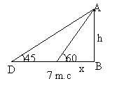 Sol:From the figure
tan 60 =
Þ
tan 45 =
Þ h = x + 7
Þ h = 
Þ h = 
= 

99. The value of  is
Ans:

Sol:cot 
= cot 
= cot tan⁻ ¹ 
= cot cot⁻ ¹ =

100. The statement p ® (q ® p) is equivalent to

Ans: Clearly p ® (p Ú q)

101. Let A be a 2 ´ 2 matrix with real entries. Let……

Ans: Statement 1 is true, Statement 2 is false

Sol : Let A = 
Þ A² = 
Given : A ² = I
Þ a² = d² = 1 - bc
Þ a = ± d
Case 1 a = - d
A = 
and we find that A ² = I and | A | = - 1
Case 2 a = d
A =
However, A ² = 
A ² will be I if a = 0
When a = 0, A =
and |A| = - 1
Statement 1 is true.
But, in both cases above tr(A) = 0
Therefore, statement 2 is false.

102. Statement 1 : For every natural number n ³ 2,…..

Ans: Statement 1 is true, Statement 2 is true; Statement 2 is a correct explanation for Statement 1

Sol : AM > GM

>
>
 >
Statement 1 is true
Statement 2 is true
From statement 2, we get
 for n ³ 2

> 1 + 
> 1 +
> 1 + 
> , since 1 - > 0
Statement 1 is a correct explanation for statement 1
103. Statement 1 : 
Ans: Statement 1 is true, Statement 2 is true; Statement 2 is a correct explanation for Statement 1

Sol:(1 + x)^{n} = C₀ + C₁x + C₂x² + .. + C_{n}x^{n}
n(1 + x)^{n- 1} = C₁ + C₂ ´ 2x + C₃ ´ 3x² + .
+ C_{n} ´ nx^{n-1}
nx (1 + x)^{n- 1} = C₁x + C₂ ´ 2x² + C₃ ´ 3x³ +..
+ C_{n} ´ nx³
(1 + x)^{n} + nx(1 + x)^{n- 1}
= C₀ + C₁(1 + 1)x + C₂ (2 + 1)x² +
+ C_{n}(n + 2)x^{n}
= 
Statement 2 is true and Statement 1 follows from Statement 2 by substituting x = 1 is Statement 2.

104. In a shop there are five types of ice-creams…..

Ans: Statement 1 is false, Statement 2 is true

Sol:Statement 1
The required number is the number of non negative integral solutions of the equation
x ₁ + x₂ + x₃ + x₄ + x₅ = 6
is ⁽⁶ ⁺ ⁵ ⁻ ¹⁾C₅ ₋ ₁ = ¹⁰C₄
Statement 1 is false
But statement 2 is true,
Since the number of ways = 

105. Let p be the statement “x is an irrational number”

Ans: Statement 1 is false.
Statement 2 is true.

Sol:p: x is irrational
q : y is transcendental
r : x is rational if and only if y is true.
Statement 1 – r º p Ú q
Statement 2 - r º ~ (p« ~q)
r º (p Ú q) Ù (~q Ú ~ p)
º (p Ú q) Ù ~ (p Ù q) º false
Statement 1 is false

AREAWISE DISTRIBUTION OF QUESTIONS FOR PHYSICS

Sl.  No. | Name of the Area | No. of Questions | Difficulty Level |  |  | Percentage
Sl.  No. | Name of the Area | No. of Questions | No. of E | No. of M | No. of D | Percentage
1 | Mechanics | 13 | 3 | 8 | 2 | 37.14
2 | Properties of Matter | 3 | 1 | 2 | 0 | 8.57
3 | Heat &  Thermodynamics | 2 | 0 | 1 | 1 | 5.71
4 | Electricity & Magnetism | 9 | 3 | 6 | 0 | 25.71
5 | Optics | 1 | 1 | 0 | 0 | 2.85
6 | Modern Physics | 5 | 3 | 2 | 0 | 14.28
7 | Electronics &  Communications | 2 | 0 | 1 | 1 | 5.71
 | Total: | 35 | 11 | 20 | 4 | 100
 | Percentage:

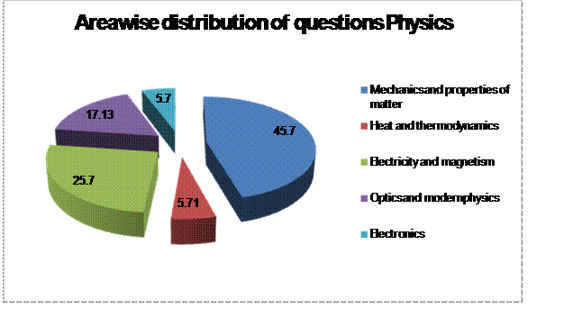
AREAWISE DISTRIBUTION OF QUESTIONS FOR CHEMISTRY

Sl.  No. | Name of the Area | No. of Questions | Difficulty Level |  |  | Percentage
Sl.  No. | Name of the Area | No. of Questions | No. of E | No. of M | No. of D | Percentage
1 | Physical Chemistry | 15 | 5 | 8 | 2 | 44.1
2 | Organic Chemistry | 10 | 6 | 4 | -- | 29.4
3 | Inorganic Chemistry | 9 | 4 | 5 | -- | 26.5

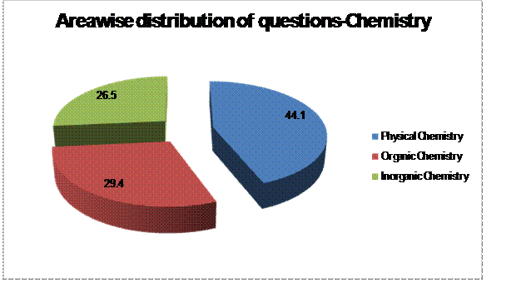

AREAWISE DISTRIBUTION OF QUESTIONS FOR MATHEMATICS

Sl.  No. | Name of the Area | No. of Questions | Difficulty Level |  |  | Percentage
Sl.  No. | Name of the Area | No. of Questions | No. of E | No. of M | No. of D | Percentage
1 | ALGEBRA | 13 | 6 | 4 | 3 | 37.14
2 | COORDINATE GEOMETRY | 4 | 2 | 2 | - | 11.42
3 | DIFFERENTIAL CALCULUS | 4 | 1 | 3 | - | 11.42
4 | TRIGONOMETRY | 2 | 2 |  | - | 5.74
5 | VECTORS, 3-D, MATRICES & DETERMINANTS | 7 | 4 | 3 | - | 20
6 | INTEGRAL CALCULUS | 5 | 2 | 2 | 1 | 14.28

