CBSE CLASS XII ZOOLOGY
Understanding Human Diseases

One mark questions with answers
Q1. What is the full form of AIDS?
Ans1. Acquired Immuno Deficiency Syndrome.
Q2. Define disease agents.
Ans2. A disease agent is a factor (substance or force) which causes a disease by its excess, or deficiency, or absence.
Q3. Name two congenital diseases.
Ans3. Alkaptonuria, Haemophilia.
Q4. What is vaccinotherapy?
Ans4. The use of a vaccine or immunity producing preparation for the treatment of a disease is called vaccinotherapy.
Two mark questions with answers
Q1. Distinguish between antibodies and interferons.
Ans1.
Antibodies | Interferons
1. They act against bacteria and viruses. | 1. They act only against viruses.
2. They act inside the cells. | 2. They act outside the cells.
3. They are slow in action. | 3. They are quick in action.
4. Their action is long lasting. | 4. Their action is temporary.
Q2. What are interferons?
Ans2. Interferons constitute a special defence system that works specifically against viral infections. It has no effect on micro-organisms. Interferon is an anti-viral protein produced by cells invaded by a virus. It is released from the infected and dying host cell. When it reaches the nearby uninfected cells, it makes them resistant to the virus infection. Resistance is provided by the formation of certain proteins which prevent the multiplication of the virus. Fever increases the production of interferons. They have proved effective in the treatment of influenza.
Q3. How would you differentiate between infection, contamination and infestation?
Ans3. Infection is the entry and multiplication of pathogens (viruses and bacteria) in the body of larger organisms, resulting in a disease.
Contamination is the presence of disease-causing agents in non-living materials such as water, milk and food, used by the host.
Infestation is the lodgement, development and reproduction of parasites, generally arthropods, on the surface of the body or in the clothing, e.g., louse infestation.
Q4. How does an endogenous pyrogen work? What is its source?
Ans4. An endogenous pyrogen is a protein released by macrophages. It brings about rise in the body temperature, causing fever, i.e., a systemic inflammatory response.
When enough pyrogens reach the brain, the body's thermostat is reset to a higher temperature, allowing the temperature of the entire body to rise. Higher body temperature reduces blood iron level. Bacteria need more iron as the temperature rises. In a fever-ridden body, bacterial growth is reduced. This constitutes the body's natural defence against microbes.
Three mark questions with answers
Q1. Distinguish between antigens and antibodies.
Ans1.
Antigens | Antibodies
1. Antigen is a foreign material that brings about antibody formation. | 1. Antibody is a molecule synthesized to combat foreign material.
2. Antigen is a protein or polysaccharide molecule. | 2. Every antibody is a protein molecule.
3. Antigen may occur as a free molecule or on the surface of a microbe. | 3. Antibody occurs on the surface of plasma cell and also in the body fluids.
4. Antigen binds to a macrophage to reach a helper T-cell to initiate immune response. | 4. Antibody directly joins an antigen to destroy the latter.
Q2. How do pathogens cause disease?
Ans2. Pathogens cause disease in two ways :
(a) Tissue Damage : Lung tissue gets damaged by the bacteria of pulmonary tuberculosis.
Brain tissue is damaged by the rabies virus.
(b) Secretion of Toxins : Powerful poisons called toxins are produced by several microbes, causing disease.
There are two types of toxins :
(i) Exotoxins : These are toxins that are released as soon as they are produced. Botulism or food poisoning, tetanus, diptheria and scarlet fever are diseases caused by exotoxins.
(ii) Endotoxins : These are toxins that are retained in the bacterial cells and are released only when the bacteria die or disintegrate. They cause dysentery, cholera, typhoid and bubonic plague.
Q3. What are the differences between active and passive immunity?
Ans3.
Active Immunity | Passive Immunity
1. When the body's own cells produce antibodies in response to infection or vaccination, immunity is said to be active. | 1. When antibodies produced in other organisms are injected into a person to counteract the antigen, immunity is said to be passive.
2. It is long lasting. | 2. It is not long lasting.
3. It takes time for the antibodies to form. | 3. It gives immediate relief.
4. It is harmless. | 4. Foreign antibodies may cause reaction and the body may destroy them by forming its own antibodies.
Q4. What are Koch's postulates?
Ans4. Robert Koch, a German microbiologist, performed some experiments on sheep that had died of anthrax. He then identified a set of form conditions that must be fulfilled if the disease causing character of any organism is to be proved.
Given below are Koch's postulates :
(a) The organism (pathogen) must be found regularly in the body of the animal that is suffering from a disease.
(b) It must be isolated and grown in pure culture on artificial media.
(c) When a healthy animal is inoculated with this culture, it must contract the disease and show the symptoms characteristic of the disease.
(d) The same organism must be recovered from the inoculated animal.
Although these postulates were originally applied for animal diseases, they are equally applicable to human diseases. They are inapplicable to viral diseases as viruses cannot be cultured on artificial media.
Five mark questions with answers
Q1. Describe the cell-mediated immune system of our body.
Ans1. Cell-mediated immune system (CMIS) : There are highly specialized cells circulating in the blood and tissue that are defensive in action. They protect the body against pathogens like protists and fungi which have entered the host's cells. This system also reacts against tissue transplants and perhaps against the body's own cells if they become cancerous.
CELLS OF THE IMMUNE SYSTEM : Lymphocytes are the chief cells of the immune system of the body. These are of two types - T-cells and B-cells. Both develop from the stem cells in the foetal liver and the adult bone marrow cells. Some lymphocytes migrate to the thymus and differentiate under its influence. They are called T-cells.
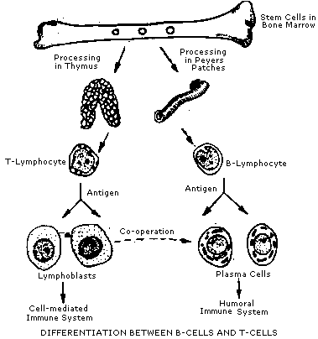
Some cells remain in the bone marrow for differentiation. They are called B-cells. The final maturation of young lymphocytes takes place in lymphoid tissues like lymph nodes, spleen and tonsils. T-cells are responsible for cellular immunity and B-cells for humoral immunity. B-cells produce about 20 trillion antibodies per day. Both B-cells and T-cells require antigens to be triggered into action, but their response is different.
Mode of action of B-cells : When antigens enter a tissue fluid, B-cells are stimulated to produce antibodies. There are thousands of antigen-specific B-cells in the body. The membrane of each B-cell type would have been sensitized by previous contact with the antigen. If this does not happen, B-cells are quickly destroyed, but new ones will go on being produced. Once an antigen-specific B-cell is activated by the antigen, it multiplies very fast to form a clone of plasma cells. These produce antibodies at the rate of 2000 molecules per second. This capacity of the B-cells to produce specific antibodies is acquired during its process of development and maturation even before it was ever exposed to an antigen.
Mode of action of T-cells : Like B-cells, T-cells also respond to antigens by producing a clone of cells. There are antigen-specific T-cells. Thus, there are different types of T-cells for every type of antigen. The life span of T-cells is 4-5 years or even more. According to their function, T-cells are classified as follows :
(a) Killer T-cells attack directly and destroy antigens. Killer cells move to the site of invasion, produce chemicals that attract phagocytes and stimulate them so that they can feed more vigorously on antigens. They also produce substances that attract other T-cells.
(b) Helper T-cells : These cells stimulate B-cells to produce more antibodies.
(c) Suppressor T-cells : These cells suppress the entire immune system keeping it from attacking the body cells. Some of these cells also become memory cells. They also stimulate the killer T-cells to destroy the non-self cells. They "help" B-cells and killer T-cells by secreting "helping factors".
(d) Memory T-cells : As soon as the same pathogen infects the body again, these cells are ready to attack the former.
Q2. What is allergy? What are its causes and symptoms? Briefly describe some allergic disorders.
Ans2. An allergy is an inappropriate immune response of the body to a harmless substance that comes in contact with the body or enters it. A substance that causes an allergy is called an allergen. Common allergens are dust, dust mites, pollen, feathers, fur, milk, eggs, fish, some drugs like penicillin, cold, heat, plants etc.
Symptoms :
- Mucous membranes of the nose, eyes and upper respiratory tract are affected in hay fever, causing swollen, reddened and running eyes and nose.
- The lower respiratory tract is the part of the body affected in asthma, leading to difficulty in breathing.
- The skin becomes red and blistered in eczema.
Cause : Whenever an allergic reaction takes place, mast cells release increased amounts of histamine. Histamine dilates the peripheral blood vessels. Suddenly, the capillaries become highly permeable, so that large amounts of fluid leak out from the blood into the tissues. A drastic drop in blood pressure can result in death within a short time.
If a person has to be properly treated, the nature of the substance to which he/she is hyper-sensitive to must be known.
Anaphylactic shock is an allergic reaction involving all the tissues of the body. Histamine released by the ruptured mast cells causes dilation of all the arteries, and a large quantity of fluid passes from the blood to the tissues leading to a marked fall in blood pressure. If an individual is allergic to penicillin, and happens to be given an injection of penicillin, the reaction is so severe that death is almost immediate, preceded by loss of consciousness. Hay fever and asthma respond to antihistamine drugs.
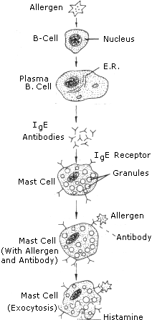
Q3. What do you know about AIDS. What measures should be taken to prevent the spread of the disease?
Ans3. AIDS is a fast spreading, incurable disease : a health problem that threatens the entire human population.
It is a disorder of the cell mediated immune system of the body whereby there is a reduction in the number of helper T-cells which stimulate the antibody production by B-cells, resulting in the loss of natural defence against viral infection.
AIDS is caused by a virus called HIV or human immuno deficiency virus. It was first seen in homosexuals in USA in 1981. The AIDS virus was isolated and identified by Professor Luc Montagnier in France and Professor Robert Gallo in USA, independently.
It was first detected in India in 1986, in Chennai.
It is thought that the AIDS virus may have passed from a monkey host into the human population in Africa during the 1960s.
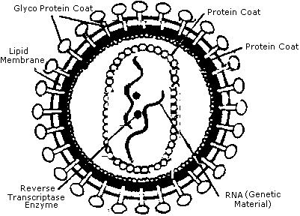
SOME PREVENTIVE MEASURES (PROPHYLAXIS) :
(a) AIDS awareness should be spread.
(b) Disposable needles and syringes must be used.
(c) Routine screening of blood should be done in blood donors, pregnant women, donors of semen and patients undergoing haemodialysis.
(d) Sexual relationship should be monogamous.
(e) High risk groups should refrain from donating blood.

